# Description

The player controls a ship. Arrow keys turn the ship left and right. Up arrow fires thrusters. Ship always appears at center of screen. Ship movement is indicated by scrolling background (all other objects shift when ship moves). The ship shoots with space bar.

Asteroids “float” around the ship. If an asteroid hits the ship, it breaks apart and the ship takes damage. If a bullet hits an asteroid the asteroid breaks apart. When asteroids get small enough they disappear. New asteroids randomly enter the screen at an increasing rate.

Game is over when the ship has taken too much damage. The goal is to survive as long as possible.

# Screenshot

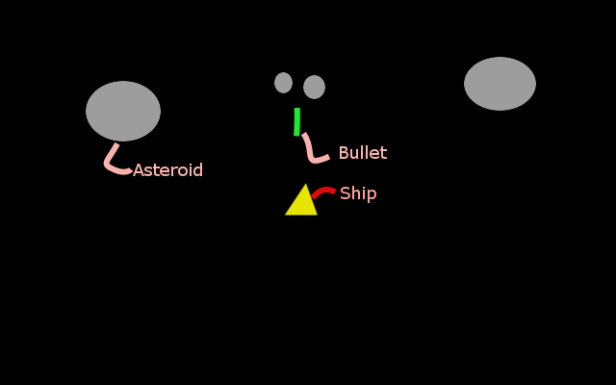

# Milestones

1. Draw a ship on the screen. -- done
2. Rotate the ship with arrow keys. -- done
3. Shoot bullets with space. -- DONE
4. Generate asteroids. -- done
5. Make objects scroll when ship moves.-- done
6. Make asteroids break apart when they hit a bullet. -- done
7. Remove bullets when they get too old; -- done
8. Remove asteroids when they hit the ship. -- done
9. Make the ship take damage when hit by an asteroid. -- done
10. Make ship explode when it takes too much damage. -- done
11. Make asteroids disappear when they get too small. -- done
12. Add a timer at the top of the screen -- done
13. Display a health bar near the ship -- done
14. Make ship stop shooting and moving after explosion -- done
15. Stop timer at end of game -- done

# Use Cases

|  |  |  |
| --- | --- | --- |
| **Program State** | **Event** | **Program Response** |
| Start of game |  | Ship is at full health, no asteroids, ship is in center of screen facing top |
| Game is ongoing | Left arrow key is pressed | Ship turns left |
|  | Right arrow key is pressed | Ship turns right |
|  | Space is pressed | Bullet is launched from ship in direction of the ship |
|  | Up arrow is pressed | All objects except for the ship move in direction opposite the ship. (ship appears to move forward) |
|  | Bullet hits asteroid | Asteroid breaks into 2 pieces moving away from each other perpendicular to bullet. |
|  | Asteroid hits ship | Ship takes damage, asteroid breaks into two parts moving away from ship |
|  |  |  |
| Game is ongoing |  | Asteroids randomly enter from edge of screen |
|  | Asteroid gets too small | It is removed from the game4 |

# Class Diagram

